# SQL FROM 4.1

**CREATE TABLE PERSONAL DETAILS AND ARRANGE THEM IN ASCENDING ORDER:**

THE TABLE AFTER CREATING AND INSERTING DATA:

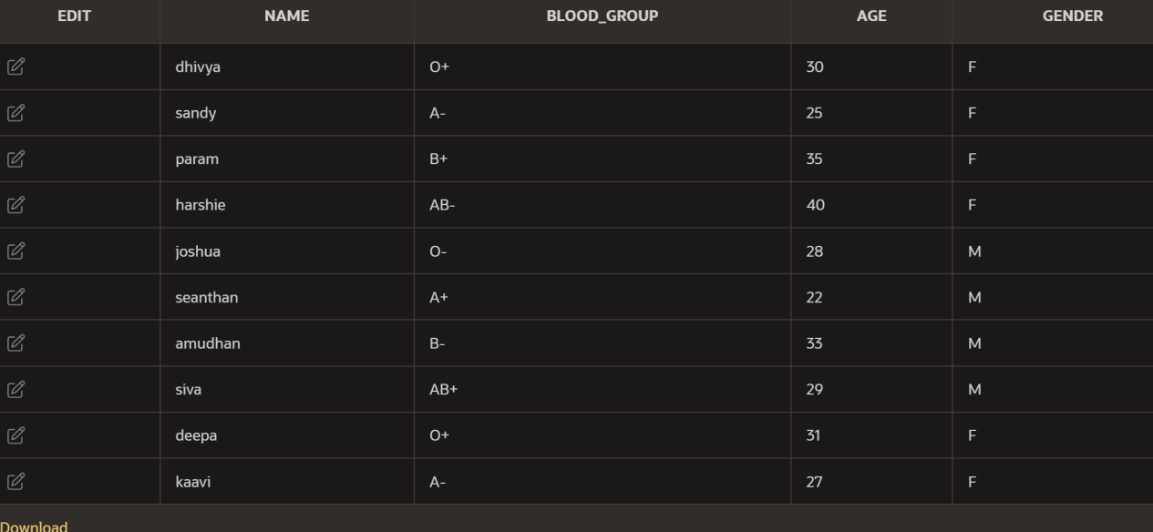

DECLARE

CURSOR my_cursor IS

SELECT name,blood_group,age,gender

FROM personal_details

ORDER BY blood_group ASC;

my_record my_cursor%ROWTYPE;

BEGIN

OPEN my_cursor;

LOOP

FETCH my_cursor INTO my_record;

EXIT WHEN my_cursor%NOTFOUND;

DBMS_OUTPUT.PUT_LINE(my_record.name|| ' ' ||my_record.blood_group|| ' ' ||my_record.age|| ' ' ||my_record.gender);

END LOOP;

CLOSE my_cursor;

END;

**OUTPUT:**

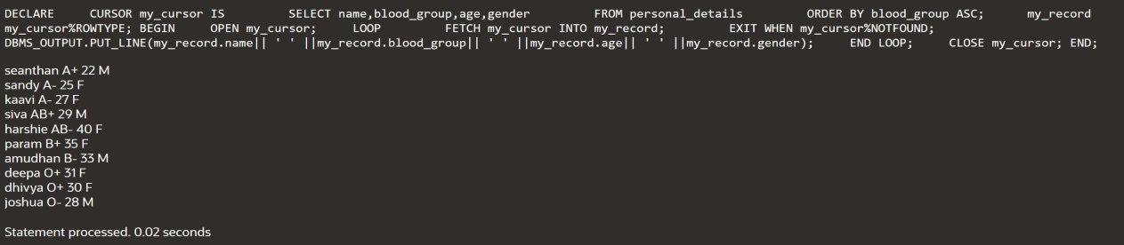

**Using the FORALL statement with SQL%BULK_ROWCOUNT:**

* **Create table:**

CREATE TABLE num_table (

n NUMBER

);

DECLARE

TYPE num_list_type IS TABLE OF NUMBER

INDEX BY BINARY_INTEGER;

v_nums num_list_type;

BEGIN

v_nums (1) := 1;

v_nums (2) := 3;

v_nums (3) := 5;

v_nums (4) := 7;

v_nums (5) := 11;

FORALL i IN v_nums.FIRST .. v_nums.LAST

INSERT INTO num_table (n) VALUES (v_nums (i));

FOR i IN v_nums.FIRST .. v_nums.LAST

LOOP

DBMS_OUTPUT.PUT_LINE ('Inserted '||

SQL%BULK_ROWCOUNT (i) || ' row (s)' ||

' on iteration ' || i );

END LOOP;

END;



* **CREATE TABLE FOR N AND N1 AND ADD THEM:**

DECLARE

TYPE num_list_type IS TABLE OF NUMBER

INDEX BY BINARY_INTEGER;

v_n num_list_type;

v_n1 num_list_type;

BEGIN

v_n(1) := 1;

v_n(2) := 3;

v_n(3) := 5;

v_n(4) := 7;

v_n(5) := 11;

v_n1(1) := 10;

v_n1(2) := 30;

v_n1(3) := 50;

v_n1(4) := 70;

v_n1(5) := 110;

FORALL i IN v_n.FIRST .. v_n.LAST

INSERT INTO num_table1 (n, n1, n2) VALUES (v_n(i), v_n1(i), v_n(i) + v_n1(i));

FOR i IN v_n.FIRST .. v_n.LAST

LOOP

DBMS_OUTPUT.PUT_LINE('Inserted values: ' ||

'n=' || v_n(i) || ', ' ||

'n1=' || v_n1(i) || ', ' ||

'n2=' || (v_n(i) + v_n1(i)));

END LOOP;

END;

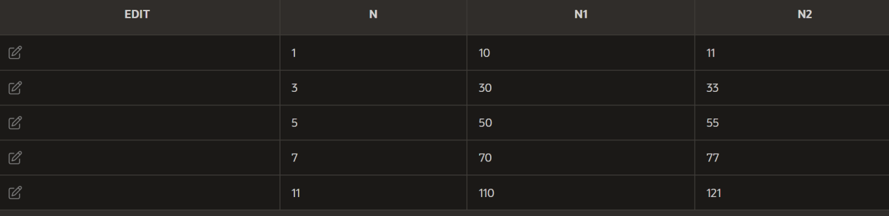

**GOTO:**

DECLARE

a number(2) := 30;

BEGIN

<<loopstart>>

WHILE a < 50 LOOP

dbms_output.put_line ('value of a: ' || a);

a := a + 1;

IF a = 35 THEN

a := a + 1;

GOTO loopstart;

END IF;

END LOOP;

END;

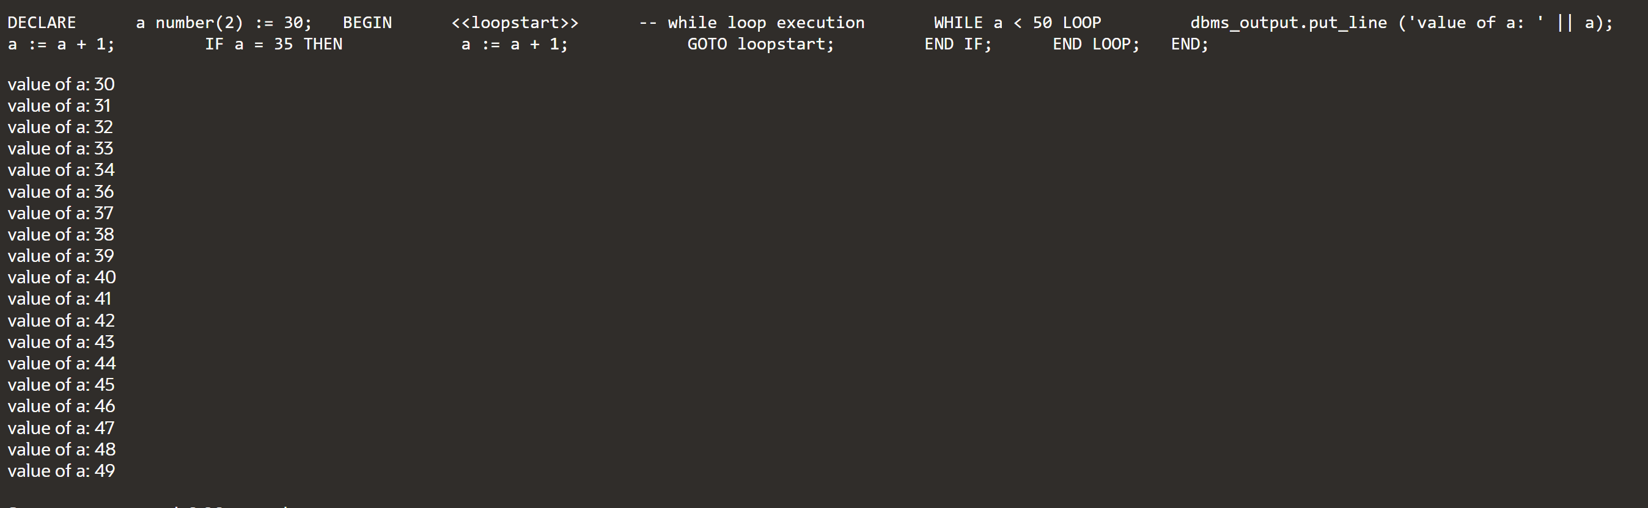

**HANDLING EXCEPTION WHEN A DIVISION BY ZERO OCCURS:**

DECLARE

dividend NUMBER := 10;

divisor NUMBER := 0;

result NUMBER;

BEGIN

BEGIN

result := dividend / divisor;

DBMS_OUTPUT.PUT_LINE('Result: ' || result);

EXCEPTION

WHEN ZERO_DIVIDE THEN

DBMS_OUTPUT.PUT_LINE('Error: Division by zero');

END;

END;



**NO DATA FOUND:**

* **Handle the NO_DATA_FOUND exception when retrieving a row from a table and no matching record is found:**

DECLARE

emp_name VARCHAR2(100);

emp_id NUMBER := 225;

BEGIN

BEGIN

SELECT first_name INTO emp_name FROM employee2 WHERE employee_id = emp_id;

DBMS_OUTPUT.PUT_LINE('Employee Name: ' || emp_name);

EXCEPTION

WHEN NO_DATA_FOUND THEN

DBMS_OUTPUT.PUT_LINE('Error: No matching record found');

END;

END;

**TABLE:**

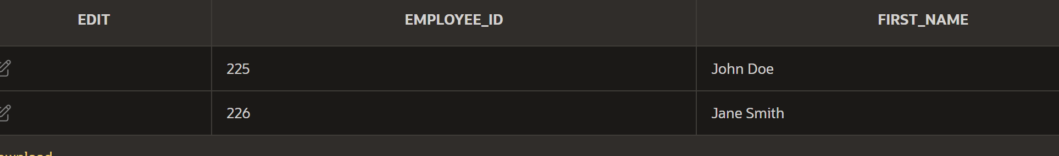

**OUTPUT:**

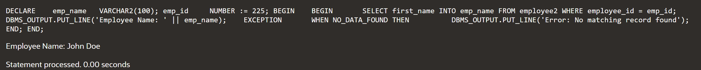

* **Handle the TOO_MANY_ROWS exception when retrieving multiple rows instead of a single row from a table.**

CREATE TABLE employee3 (

employee_id INTEGER PRIMARY KEY,

first_name VARCHAR2(25),

last_name VARCHAR2(25),

email VARCHAR2(25),

phone_number VARCHAR2(15),

hire_date DATE,

job_id VARCHAR2(25),

salary INTEGER,

commission_pct NUMBER(5,2),

manager_id INTEGER,

department_id INTEGER

);

INSERT INTO employee3 (employee_id, first_name, last_name, email, phone_number, hire_date, job_id, salary, commission_pct, manager_id, department_id)

VALUES (1, 'seanthan', 'amudhan', 'seanthan@gmail.com', '123-456-7890', TO_DATE('2020-01-15', 'YYYY-MM-DD'), 'IT_PROG', 6000, 0.10, 0, 90);

INSERT INTO employee3 (employee_id, first_name, last_name, email, phone_number, hire_date, job_id, salary, commission_pct, manager_id, department_id)

VALUES (2, 'sandy', 'murugan', 'sandy@gmail.com', '123-456-7891', TO_DATE('2019-03-23', 'YYYY-MM-DD'), 'HR_REP', 5000, 0.05, 1, 90);

INSERT INTO employee3 (employee_id, first_name, last_name, email, phone_number, hire_date, job_id, salary, commission_pct, manager_id, department_id)

VALUES (3, 'dhivya', 'joshua', 'divejosh@gmail.com', '123-456-7892', TO_DATE('2018-07-30', 'YYYY-MM-DD'), 'SA_REP', 5500, 0.15, 0, 91);

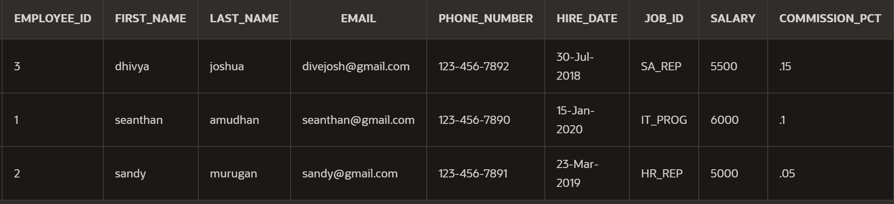

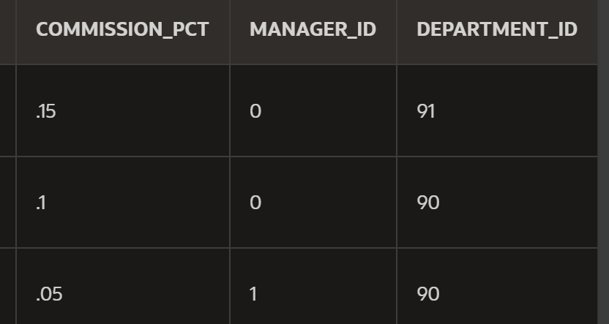

DECLARE

v_dep_id employees.department_id%TYPE := 90;

v_emp_id employees.employee_id%TYPE;

v_emp_name employees.first_name%TYPE;

v_emp_salary employees.salary%TYPE;

v_exception_msg VARCHAR2(200);

BEGIN

SELECT first_name, department_id, salary

INTO v_emp_name,v_dep_id, v_emp_salary

FROM employees

WHERE department_id = v_dep_id;

EXCEPTION

WHEN TOO_MANY_ROWS THEN

v_exception_msg := 'Multiple rows found for the given department ID: ' || v_dep_id;

DBMS_OUTPUT.PUT_LINE(v_exception_msg);

WHEN OTHERS THEN

v_exception_msg := 'An error occurred: ' || SQLERRM;

DBMS_OUTPUT.PUT_LINE(v_exception_msg);

END;

**OUTPUT:**

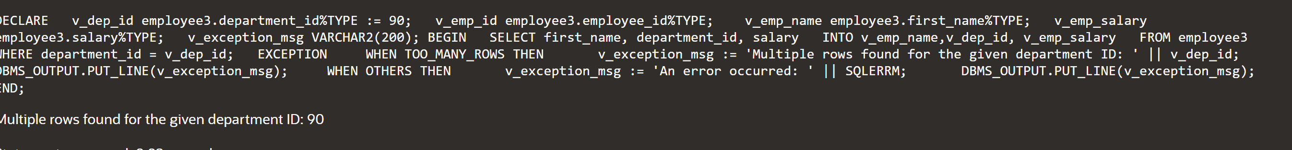

**Handle the INVALID_NUMBER exception when converting a non-numeric value to a number:**

DECLARE

v_input VARCHAR2(10) := 'abc';

v_number NUMBER;

BEGIN

BEGIN

v_number := TO_NUMBER(v_input);

DBMS_OUTPUT.PUT_LINE('Conversion successful. Number: ' || v_number);

EXCEPTION

WHEN INVALID_NUMBER THEN

DBMS_OUTPUT.PUT_LINE('Error: Invalid number');

END;

EXCEPTION

WHEN OTHERS THEN

DBMS_OUTPUT.PUT_LINE('Error: ' || SQLERRM);

END;

**OUTPUT:**

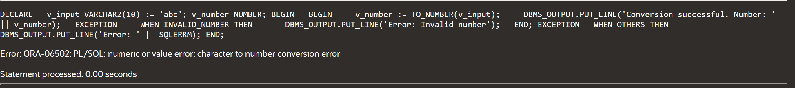

**Handle the DUP_VAL_ON_INDEX exception when inserting a duplicate value into a table with a unique constraint:**

DECLARE

v_duplicate_value NUMBER := 125;

BEGIN

BEGIN

INSERT INTO employees (employee_id) VALUES (v_duplicate_value);

DBMS_OUTPUT.PUT_LINE('Insertion successful.');

EXCEPTION

WHEN DUP_VAL_ON_INDEX THEN

-- Handle the exception

DBMS_OUTPUT.PUT_LINE('Error: Duplicate value already exists.');

-- You can perform additional error handling or logging here

END;

END;

**BEFORE:**

**AFTER:**

